1. Project proposal
   1. Introduction

Addis Ababa University (AAU), established in 1950 is the oldest and largest higher learning and research institute in Ethiopia. Today, AAU has more that 33,000 undergraduate students and over 2,000 academic staff in its 14 campuses.1 Creating a conducive learning environment is a multifaceted challenging feat. Part of the challenge comes from the number of moving parts involved in making the University function in harmony — the academic staff, supporting staff, student body, administration, leadership and many more.

One of these parts, important in the teaching-learning process, is the communication between students and their instructors. Most commonly, instructors relay message to students through a class representative, an assigned student for each section. This representative has the responsibility of making sure every student in the section receives the announcement, the handout copy or any other information. Aside from the class representative, staff members use the noticeboard to post announcements.

In November of 2015, during our first year at the Department of Computer Science, we noticed the inefficiency of the communication. With this problem in mind, we built AAU Push. A website that gives teachers a simple way to post announcements and upload course textbooks, references and assignments for students. Students receive these information through the website and the Android application. A similar system, made by an American company, called Piazza ([piazza.com](http://piazza.com)) is used by the Software Engineering Department at Addis Ababa Institute of Technology.

The utility of AAU Push was evident over the following two years as the staff of Department of Computer Science used it to communicate to students. It relieved unnecessary pressure from the class representative and empowered instructors to be more interactive in and outside of class. Currently this system is to be placed to all departments in the College of Natural and Computational Sciences (CNCS) under the recommendation of the dean of CNCS.

Although this system is good and helpful, it is not without shortcomings. In this project we seek to find out problems in this current system and improve its usability, practicality and adoption.

1 <http://www.aau.edu.et/about/aau-at-glance/>, accessed December 27, 2018

* 1. Statement of the Problem and Justification

AAU Push (Push) currently requires both instructors and students to signup and login to use the website. There, instructors share information, announcements or files like assignments, references and PDF handouts.

The system is faces multiple limitations:

1. The communication on the platform only allows flow of information in one way that is instructor to student. This is mean students don't have a way to ask questions or submit assignments.
2. The system only works over the internet. When file sizes exceed a certain limit, downloading the resources will be difficult. Large file sizes also incur higher costs for server space.
3. Although the system has had an Android app for students, it is now out of date and useless. Furthermore, there is not application available for iOS users and Instructors.
4. Instructors has reported several usability issues on the interface.

In addition to these limitations, there are many more features that can be added to the system to enhance the teaching-learning experience. Fixing these issues and developing the system further will help students be well informed and productive because AAU Push delivers, in one place, all information from teachers in the most organized manner. It will also help instructors be at ease and reassured because Push lets them reach all their students in the fastest, reliable and convenient way from anywhere at anytime.

* 1. Project Objective
     1. General Objective of the System

The general objective of this project is to create e-learning communication platform to aid the instructor-student relationship.

* + 1. Specific Objective of the System
* Document and analyze the current system
* List the shortcomings to the current system
* Gather list of features to add and errors to correct
* Develop features as needed
* Test and deploy the new system
  1. Scope of the Project

This project will develop the current system to:

* Enable Instructors to edit and delete their posts
* Have local servers to increase speed and availability
* Have Android and iOS apps
* Allow students to submit assignments and ask questions
* Create accounts to be used by College Dean and Registrar Offices
  1. System Development Methodology

Since our system is driven by user interface requirements, we will be using Rapid Application Development as our software development approach. We will be putting less emphasis on planning and more emphasis on an adaptive process — prototyping, testing and documenting when approved.

* + 1. Investigation (Fact-Finding) Methods

We will be investigating the pros and cons of the current system by using the following methods:

* Survey: collect comments from students
* Interview: ask instructors and students in-depth of what they think of the product
* Observation: see how instructors use the product to find usability issues
* Research: review the landscape of similar e-learning solutions to make note of what could be missing from AAU Push
  + 1. System Development Tools
* Laptop with any operating system and recommended with Core i5 Processor, 4 GB RAM or higher.
* Any Android Phone with operating system Android 4.1 minimum
* iOS device with operating system iOS 9.0 minimum
* Python is used as the language to develop the backend of the system with Django framework. Django is a high-level web framework which was created for quick web project development. It delivers transparent and high-quality code writing, making it important for developers, and equally important for customers.
* HTML, CSS and Javascript are used to build frontend interfaces along with required libraries and frameworks.
* React Native is a framework that enables web developers to create robust mobile applications using their existing JavaScript knowledge. It offers faster mobile development, and more efficient code sharing across iOS, Android, and the Web, without sacrificing the end user's experience or application quality. We use this cross-platform framework to make Android and iOS apps.
* Python will be used to develop a Telegram bot. Because there are a number of APIs available that make development faster.
  1. Significance of the Project

This solution will empower the academic staff to teach without limitations in communication. We will see an increased level of interaction with students.

Push will also let students focus their efforts on studying as opposed to stressing on how to get resources. It will help them stay informed and feel like they are on top of their work. This will result in boosted confidence and academic performance.

* 1. Beneficiaries

The beneficiaries of the new system are teaching staff members and their students.

* 1. Time Schedule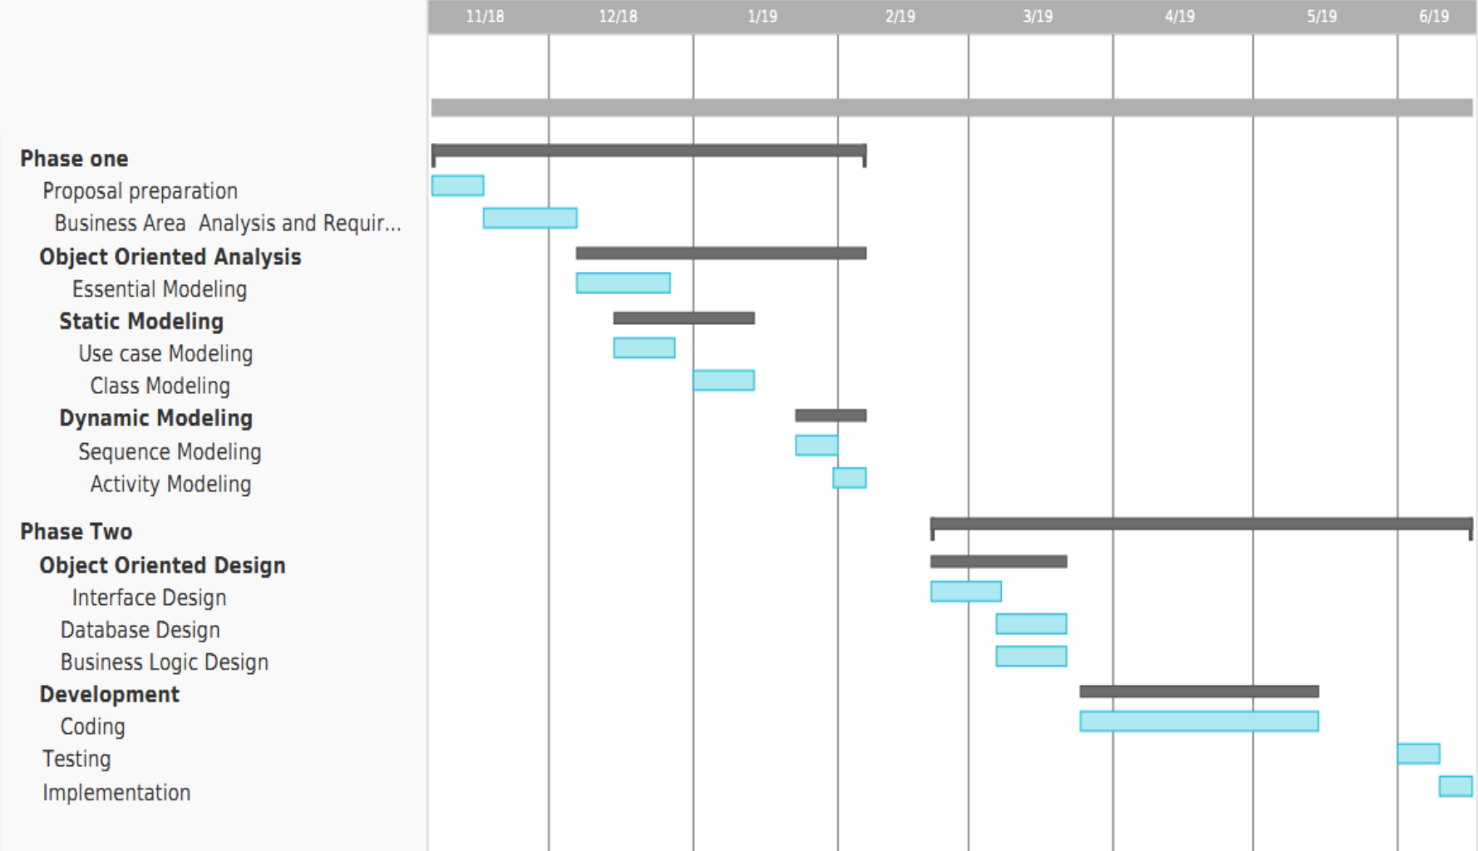

1. Requirement Analysis
   1. Introduction

The purpose of AAU Push is to serve as a communication platform between teachers and students in the college environment. In this regard, we will need to review each aspect of this communication.

* 1. Current System

There are two major ways teachers and students communicate in Addis Ababa University.

**Method One: Word of Mouth**

The first method is communication using a class representative. This is most common practice used by teachers to reach their students. It works in such a manner: each section of class has an assigned student that is in charge of communicating with the teacher. This student, called the class representative (Rep), talks to the teacher via phone to get announcements. Once the Rep is up to date with the latest information, he/she announces to all students in any of the following classes or, if available, in the social media group for the class. This social media group can be on Viber, WhatsApp, Telegram or other group chatting application available. In addition, if the students has a question, for example to request a change of date for an exam, the Rep will be the one to ask the teacher. When the teacher needs to give out handouts to the students, there are several methods utilized. The first and most common is giving a printout of the handout to the students to copy for themselves. The teacher could give that printout to the Rep or leave it at a photocopy shop nearby that students can go to. Another way teachers distribute class materials is by copying it to students’ flash drives. Typically the teacher would bring his/her laptop to the class and copy the material to all students with a flash drive at hand. Then students who did not have a flash would be responsible to get the files from their classmates. This method has one major issue that has been a problem for most teachers: the issue of computer viruses. As teachers plug and use multiple flash drives, they are vulnerable to attack from any virus present in these drives.

There is one other new way for distributing files: using social media applications. One of the most popular is Telegram, a social chatting application that has boomed in Ethiopia over he past two years. Teachers have been observed sending class files to Reps over this platform. And then the Reps would in turn forward these into the class groups for all to download. Or teachers create what is called a Channel on Telegram, this is similar to a group chat however only permits one user to send messages to the group and that user is the creator of the group. Teachers create a channel and let their students join. This way of communication is one-way. The teacher sends information on one side and students get it on the other.

**Method Two: AAU Push**

The second method of communication and the focus of this project is AAU Push. A website used in Addis Ababa University, and more specifically in the Department of Computer Science. Development of this website started in late 2015 by computer science students and is still maintained by them. It is currently a one-way communication platform that seeks to bridge the communication gap between teachers and students with a focus on the undergraduate program. It allows teachers to post announcements and materials for all their students at once. For this system to serve its purpose, it requires two parties to be present, all the students of the department and their instructors. Let us see in detail how this system works.

The system is first initialized. The department provides its name, course offering and number of year of the program with the sections available. Once this is fed into the system, it is ready to onboard students and teachers.

Initially, all students of the department are made to signup on the homepage of the website. There each student will enter his/her name, ID, year, section and phone number. By signing up, they are automatically subscribed to all the courses their section is taking. Once they complete signing up, they are able to login using their ID and password. Upon login, they reach the Student Dashboard.

At the Dashboard, there are a number of tabs on the menu. The first enables them to view the latest announcements. On the next tab titled ‘Courses’, all the courses a student is subscribed to at listed. Students can click on the title of the course to see all the materials that have been uploaded by their teachers. They can download the material simply by clicking on the title of the document.

The following tab in the menu is ‘Add/Drop’. Although students are automatically subscribed to all courses their section takes, it does not mean that a particular student is taking all of them in reality. Students add and drop courses from one semester to another because of many factors. To reflect this reality, students can unsubscribe a course by ‘dropping’ it in the ‘Add/Drop’ menu. Conversely, they are also able to add a course by specifying from which year and section they are taking it from. That way, announcements and materials for that course will appear in their Dashboard.

The next tab is ‘Account’ where students can update their personal and contact information. Following the ‘Account’ tab is a logout button to exit the system. This concludes the list of functionalities students receive through Push. Let us now see how Push is used by teachers.

Teachers are registered on to the website by invite only. An Excel sheet with the list of email of faculty members (or instructors) of the department, for example Department of Computer Science, is collected from the department. Once Excel file is fed into the system, Push creates users and sends out automated invitations to all instructors to join and activate their accounts. This email contains the email and temporary password that the instructor uses to login. Once an instructor open this email, they can use the credentials provided to login into the system. On their first login, he/she is asked to fill in full name and create a new password for their account. After this step they will have access to the Instructor Portal where they are able to send announcements and upload materials to their students.

Once at the Portal, instructors see a form on a tab titled ‘Post’. This form has a field to write the message of the announcement. Once instructors write their message, they pick the section they would like to send it to by ticking on the section from the list in a section titled ‘Send To’. This section holds the list of sections the teacher gives a course to. However, when teachers have just activated their accounts, there is nothing listed in the ‘Send To’ section because they have not yet specified what courses they are giving. To do this, they go to the tab titled ‘Class List’. There, they can browse through the departments year, then section in a hierarchical order then finally tick the course they teach each section from the list. This will update the ‘Send To’ on the ‘Post’ form.

To send an announcement, instructors write their message in the Post form, pick a section to send it to and click on ‘Send’. On the ‘Post’ instructors can attach or upload up to three 3 files and 2 images. The files will be listed as materials under the specific course on the student’s Dashboard.

Instructors can see the viewership of an announcement or material from the ‘Tracker’ tab. It displays the announcement message and the number of students that have seen it. The same is true for materials and its number of downloads.

Similar to the student’s Dashboard, the Portal has an ‘Account’ tab where instructors can update their personal information. Below that tab is a logout button to exit the system.

* + 1. Major Functions of the Current System / Current System Description
* Allow students to sign up on system using their ID, year and section
* Allow students to login to the system to access Student Dashboard
* Allow students to view announcements from their teachers
* Allow students to download materials sent from their teachers under each course
* Allow students to ‘add’ a course to start receiving notifications and materials on that course
* Allow students to ‘drop’ a course to stop receiving notifications and materials on that course
* Allow students to modify their personal information
* Allow teachers to signup to the system by email invitation
* Allow teachers to login to the system to access Instructors Portal
* Allow teachers to pick which section they are teaching and what course
* Allow teachers to send announcements to students for specific course they teach
* Allow teachers to upload materials to students for specific course they teach
* Allow teachers to see the number of students that have seen a specific announcement
* Allow teachers to see the number of students that have download a specific material
* Allow teachers to modify their personal information
  + 1. Problem of the Existing System

Over the time AAU Push has been in use, a number of issues have been seen.

Firstly, we can see that the system is not self-contained or fully automated. When teachers or students forget their passwords, the only way to reset it is by calling the administrators of the website. The admin will reset their password and give them a new one. Password recovery by email is missing from the system. Similarly, once an instructor has sent an announcement, there is no way to edit it or remove it unless an admin intervenes. This would mean that if a teacher posts the wrong information by mistake, correcting it will not be simple.

Secondly, communication over this platform is one-way only: from teachers to students. Even though there are many cases where students would need to give an input, this is not reflected on Push. For example, feature for student assignment submission and option for asking questions is missing.

Thirdly, using AAU Push to transfer large files over the internet is difficult. Push currently only works when teachers and students are connected to the internet. On normal cases, this should not be an issue. However, teachers often want to send files with large sizes like video or bulky textbooks. In this situation, it becomes difficult or time taking for teachers to send it. And then students will have to look for Wi-Fi to download that large file because it will be too expensive to do it via mobile data. So Push does not solve the need of sending large files in a fast and cheap manner.

Finally, the system is limited to a website. In todays fast and connected world, doing work on-the-go is demanded. For Push, mobile applications are currently not available.

* + 1. Requirement Gathering Methodologies

1. User Observations: We have gathered requirements by watching teachers and students interact with the system in different use cases like sign up, login, post announcement, download materials.
2. Survey: Used a Google Form to collect reviews from students.
3. User Interviews: We have collected requirements by interviewing teachers and students to find what is missing. Issues of the system and feature lists have been developed from this activity.
4. Review Other Systems: to develop feature lists, we have also researched other systems to see what needs to be added to ours.
   1. Proposed System
      1. Overview

This part of the document specifies a system that can be used to solve the current systems problems that were mentioned earlier.

* + 1. Definitions

**Year**: is the number identifying the level of the student. For example, a student entering the University would have a year of 1. The following year will be 2. The limits of the year will depend on the program the student takes.

**Section**: a distinct group within a larger body of all students in a specific year. For example, a first year student in the second section would have a Section value of 2.

Course: a series of lectures or lessons in a particular subject. For example, Introduction to Computer Science

**Class**: is a course being given to a specific year and section by an Instructor. For example, Introduction to Computer Science being given to Year 1 Section 1 students is one class. The same course given to Year 1 Section 2 students is another class.

**Post**: is a message with text and optionally files and images

**Staff:** an employee working for the University under a specific department or in the administration.

**Portal**: is the index page a Staff views when logging in to AAU Push. From there the user can access a number of functionalities.

**Dashboard**: is the index page a Student views when logging in to AAU Push.

* + 1. Functional Requirements

1. Students, Teachers (Instructors), Department Heads, Registrar Officers and the College Dean should all have accounts to access the system.
2. All users should be able to login.
3. All users should be able to log out.
4. All users should be able to recover their password through the email.
5. All accounts must be verified using the personal information provided.
6. All users should be able to participate in and create discussion forums.
7. Forum participants should be able to send and receive messages and images.
8. All users should be able to search forums by their names or forum ID.
9. Students should be able to submit assignments.
10. Students should be able to access posts sent to them from their teachers, their department head, program coordinators, registrar and the university dean.
11. Students should be able to mark posts as ‘Read’ to indicate that they have read it.
12. Students should be able to add classes to get information from teachers and drop classes to discontinue information from a specific class, so that the information displayed will be relevant.
13. Students should be able to update their account information, but they shouldn’t be able to update their name, ID or department.
14. Students should be able to access deadlines set by their teachers, for upcoming assignments, tests and projects.
15. Students should be able to submit assignments to their teachers using deadlines set for assignments.
16. Teachers should be invited to sign up via email by Department Head.
17. Teachers should be able to add classes they are teaching in order to post announcements and upload materials.
18. Teachers should also be able to remove classes that they are not teaching anymore. Teachers should specify the year and section of the courses they are giving to add their classes.
19. Teachers should be able to send posts for announcements and uploading materials. They should choose the classes they want to post to.
20. Teachers, Department Heads, College Dean and Registrar Officers should be able to see how many students got their post, how many of them marked it as ‘Read’ and how many times the material they posted was downloaded.
21. Teachers should be able to edit their announcements.
22. Teachers should be able communicate over a group chat where they can post messages to members of their departments.
23. Teachers should be able to update their account information, but they shouldn’t be able to update their department.
24. Teachers should be able to set deadlines for upcoming assignments, tests and projects.
25. Department heads should be able to post announcements and upload materials to students in his/her department. They should choose the recipient, either year or section in their department.
26. Department heads should be able to send single invites to teachers.
27. Department heads should be able to invite a single teacher or many teachers using Excel Sheets.
28. Department heads should be able to remove teacher accounts.
29. Department heads should be able to post in their department group chat.
30. Department heads should be able to participate in and create discussion forums.
31. Deans should be given accounts by the administrators. They should change their password when they login for the first time.
32. Deans should be able to post announcements and upload materials to students in his/her campus/university. They should choose the recipient, either department, year or section in their campus/university.
33. Deans should be able to only post in department group chats not read messages.
34. Registrar offices should be given accounts by the administrators. They should change their password when they login for the first time.
35. First, registrar offices should be able to post announcements and upload materials to students in his/her campus/university. They should choose the recipient, either department, year or section in their campus/university.
    * 1. Non-Functional Requirements
         1. User Interface

* All users should only be required to have basic knowledge of using computer in order to use the system.
* Deadlines for students should be displayed at all pages when the student is logged in.
  + - 1. Access Control
* Student should login using his/her ID
* Discussion forums should be either closed or open. Closed forums should be joined either by providing a code set by the forum creator or based on characteristics of the students, like year, section, department, courses and campus. Every forum should have a forum ID, name and description.
* Teachers should be able to add only courses given by their department.
  + - 1. Availability and Speed
* Local servers placed within the university’s network should host files sent by teachers. This is will increase availability and download speeds of course files. Whenever a student is within the university, Internet connection is not required to download files. This should feel seamless to the students. The data stored in local servers within the University should be up to date with the data on the cloud server. The system should have mobile applications and Telegram bot in sync with the website.
  + - 1. Documentation
* Full documentation of the system including the Project Proposal, System Requirement Analysis Document, System Design Document and the Object Design Documents will be compiled to facilitate future reference and system maintenance.
  + - 1. Usability
* To students, delivery of information from teachers is more important than delivering general announcements from the university dean, registrar or their department head. Therefore, when displaying information there should be a distinction between information from their teachers and information from their department head, program coordinators, registrar and the university dean, giving more emphasis to the first one.
* Students should specify the year and section of the courses they are taking to add their classes. Students should be able to add only courses given to their department. Students should be able to access files in a simple and organized way. Files sent from teachers to students should be classified under the class they were uploaded to and files that aren’t from teachers should be classified together.
  + - 1. Physical Environment

The system is going to be deployed at Addis Ababa University, where the system is not required to withstand any special condition.

* + - 1. Security
* Students should be able to signup online by providing their ID, Name, Department, Year and Phone number. The given information should be checked against the student information list provided by the University. And if all the information provided by a student match’s with a student record in the list, that isn’t already taken, the student should be signed up and given an account.
* When inviting teachers via email the system should create accounts and temporary passwords for teachers before inviting them. They should set up their account and change their password when they first login.
* Teachers should login using the email they were invited with.
* Department heads should be given accounts by the administrators. They should change their password when they login for the first time.
  1. System Model
     1. Actors

|  |  |
| --- | --- |
| Actor | Description |
| Student | A person who is studying at the college |
| Instructor | A member of staff of a department that teaches at least once course to a section |
| DepartmentHead | A person in charge of leading a department, its program and staff members |
| CollegeDean | The head of a college |
| RegistrarOfficer | A person holding a position at the Registrar Office |

* + 1. Use Case Model
       1. Use Case Diagram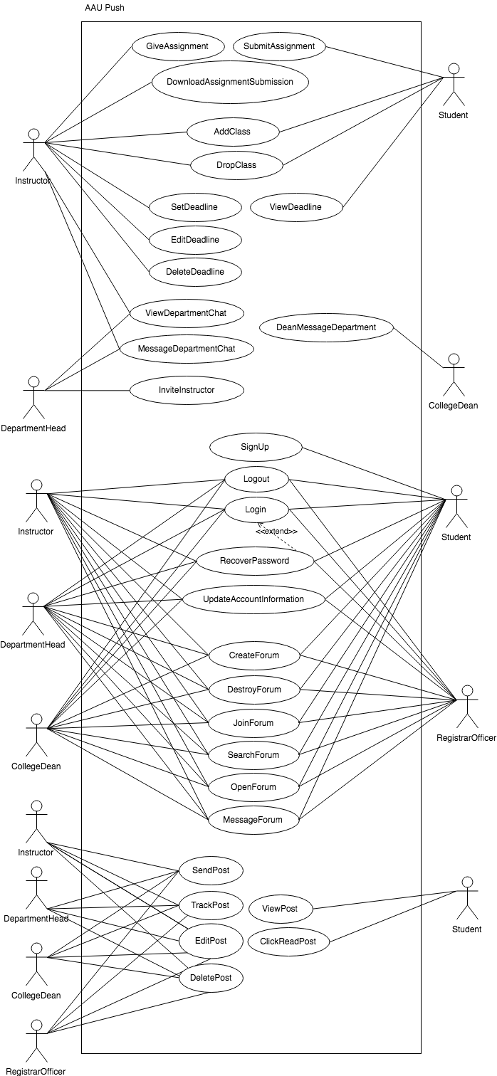
       2. Use Case Descriptions

|  |  |
| --- | --- |
| Use case name | InviteInstructor |
| Participating actors | Initiated by DepartmentHead  Communicates with Instructor |
| Entry condition | The DepartmentHead is logged in the website |
| Flow of events | 1. The DepartmentHead clicks on ‘Manage Department Data’ from the Portal. 2. Push presents a form presenting two options. First is a file upload button that accepts an Excel file. And second is a short-text area field titled ‘Invite a Staff Member’ to write the email of the instructor. 3. The DepartmentHead uploads an Excel file containing the emails of the Instructors and clicks ‘Send Invite’ button. 4. Push creates a user objects based on each email provided. Then sends a username and temporary password to each email address. 5. An invited Instructor opens the email that presents their email for login, temporary password, and a button titled ‘Setup Account Now’ which redirect to login page. 6. Push presents a login form requesting for email and password for the Instructor. 7. The Instructor fills the credentials provided in the email and is logged in. 8. Push then presents a form requesting: Title (Prof., Dr., Mr…), First Name, Last Name, Email, New Password and Confirm New Password. 9. The Instructor completes this form and clicks on ‘Complete Setup’. |
| Exit condition | The DepartmentHead has received a confirmation of the invitations that are sent and of those that are already existent in the system.  The Instructor is forwarded to the Instructor Portal. |
| Alternative Flow | If the DepartmentHead chooses to invite one Instructor, he/she writes the email of the Instructor into the text field and clicks on ‘Send Invite’. |

|  |  |
| --- | --- |
| Use case name | TrackPost |
| Participating actors | Initiated by Instructor, DepartmentHead, CollegeDean or RegistrarOfficer |
| Entry condition | The user is logged in the system |
| Flow of events | 1. The user clicks on ‘Tracker’ tab in the Portal. 2. Push presents a list of all the posts sent by the user. For each post, ‘Delivered To’ and ‘Read By’ fields indicate the number of students the announcement is sent to and number of students that have confirmed to have read it respectively. For any files attached on the post, the ‘Downloads’ label shows how many times the files have been downloaded. ‘Edit Post’ and ‘Delete Post’ buttons are also available. 3. The user views the statistics provided. |
| Exit condition |  |
| Quality requirements | If the user clicks on ‘Edit Post’ button for a specific post, the EditPost use case is initiated.  If the user clicks on ‘Delete Post’ button for a specific post, the DeletePost use case is initiated. |

|  |  |
| --- | --- |
| Use case name | EditPost |
| Participating actors | Initiated by Instructor, DepartmentHead, CollegeDean or RegistrarOfficer |
| Entry condition | The user is logged in and has initiated TrackPost use case |
| Flow of events | 1. The user clicks on the ‘Edit Post’ for a post from the list provided. 2. Push makes the text for the post an editable form. 3. The user makes the edits required to the text and clicks on ‘Update Post’ button. 4. Push propagates the edits and notifies the recipients of changes. |
| Exit condition | The user gets a confirmation that announcement has been edited. |
| Quality requirements |  |

|  |  |
| --- | --- |
| Use case name | DeletePost |
| Participating actors | Initiated by Instructor, DepartmentHead, CollegeDean or RegistrarOfficer |
| Entry condition | The user is logged in and has initiated TrackPost use case |
| Flow of events | 1. The user clicks on the ‘Delete Post’ for a post from the list provided. 2. Push prompts the user for a confirmation asking ‘Are you sure you want to delete this post?’ 3. The user confirms by clicking on ‘Yes’ 4. Push deletes the post. |
| Exit condition | The user gets a confirmation that announcement has been edited. |
| Quality requirements |  |

|  |  |
| --- | --- |
| Use case name | SignUp |
| Participating actors | Initiated by Student |
| Entry condition | The Student is on the sign up page of Push |
| Flow of events | 1. Push presents a sign up form. 2. The Student fills the sign up form on the page by inputting first name, last name, ID and Department. Then clicks on ‘Sign Up’. 3. Push then displays a form asking for year, section, password, phone number and email. 4. The Student picks their year and section from the list of available options in the drop-downs. Enters their preferred phone, email and password. Then clicks on ‘Complete Sign Up’. 5. Push registers the user. |
| Exit condition | The user receives a confirmation that a successful signup is done and is forwarded to the Student Portal. |
| Quality requirements |  |

|  |  |
| --- | --- |
| Use case name | AddClass |
| Participating actors | Initiated by Instructor or Student |
| Entry condition | The user is logged in the system |
| Flow of events | 1. The user clicks on ‘Class List’ tab in the Student Dashboard or Instructor Portal. 2. Push presents a form that lets the user pick courses by specifying year and section. 3. From the form the user ticks on the courses desired and clicks on ‘Add Class’. 4. Push updates the list of classes the user is engaged in. |
| Exit condition | The user receives a confirmation that the classes are added |
| Quality requirements | If the user is an Instructor, Push adds the list of classes the Instructor is teaching and makes them available for sending posts. If the user is a Students, Push adds the class for the Student and he/she will receive posts from that class. |

|  |  |
| --- | --- |
| Use case name | DropClass |
| Participating actors | Initiated by Instructor or Student |
| Entry condition | The user is logged in the system |
| Flow of events | 1. The user clicks on ‘Class List’ tab in the Student Dashboard or Instructor Portal. 2. Push presents a table that displays the list of classes the user is currently engaged in. 3. From the table the user clicks ‘Drop Class’ on the course to be removed. 4. Push updates the list of classes the user is engaged in. |
| Exit condition | The user receives a confirmation that the classes are dropped. |
| Quality requirements | If the user is an Instructor, Push removes the class from the list of classes the Instructor is teaching. If the user is a Student, he/she will stop receiving posts from that class. |

|  |  |
| --- | --- |
| Use case name | Login |
| Participating actors | Initiated by any user |
| Entry condition | The user has opened the login page of Push |
| Flow of events | 1. Push presents a form with two tabs ‘Student' and ‘Staff’. Under the ‘Staff’ tab are two fields, ‘Email’ and ‘Password’ and a button ‘Login’. Under ‘Student’ tab are two fields, ‘Username’ and ‘Password’. 2. If the user is a Student, user inputs their ID and password and clicks on ‘Login’. If the user is an Instructor, DepartmentHead, CollegeDean or RegistrarOfficer, user inputs their email and password and clicks on ‘Login’. 3. Push verifies that the login credentials are correct. |
| Exit condition | The user is advanced to the Portal or Dashboard |
| Quality requirements |  |
| Alternative Flow | 1. If the login credentials fail verification, the user is given a notice on the login page that the email and/or password is wrong. 2. The user can then click on ‘ForgotPassword’ button to initiate the ForgotPassword use case. |

|  |  |
| --- | --- |
| Use case name | RecoverPassword |
| Participating actors | Initiated by any user |
| Entry condition | The user is on the login page. |
| Flow of events | 1. The user clicks on ‘Forgot Password’ link below the login form. 2. Push presents a form with ‘Email’ field and a button ‘Reset Password’. 3. The user inputs their email and clicks on ‘Reset Password’. 4. Push sends a password reset link to the email provided. 5. The user opens the link from their email. 6. Push presents a webpage with a form containing two fields ‘New Password’ and ‘Confirm New Password’ and a button ‘Reset Password’. 7. The user fills the form and clicks on ‘Reset Password’. |
| Exit condition | The user receives a confirmation and redirected to the login page. |
| Quality requirements |  |

|  |  |
| --- | --- |
| Use case name | GiveAssignment |
| Participating actors | Initiated by Instructor |
| Entry condition | The Instructor is logged in the system |
| Flow of events | 1. At the Portal, the Instructor clicks on ‘Assignments’ from the menu presented. 2. The tab displays a list of assignments that have been given by the Instructor and a button, ‘New Assignment’. 3. To give a new assignment the Instructor clicks on ‘New Assignment’ button. 4. Push opens a form requiring the name, assignment definition file, deadline date (day, month and year), which class it is for and comments related to the assignment. 5. After filling the form, the Instructor clicks on ‘Give Assignment’ button. |
| Exit condition | The Instructor gets confirmation that the assignment is successfully given. |
| Quality requirements |  |

|  |  |
| --- | --- |
| Use case name | DownloadAssignmentSubmission |
| Participating actors | Initiated by Instructor |
| Entry condition | The Instructor is logged in the system |
| Flow of events | 1. At the Portal, the Instructor clicks on ‘Assignments’ from the menu presented on the left. 2. The tab displays a list of assignments that have been given by the Instructor. 3. The Instructor clicks on ‘View Submissions’ button for any of the assignments given. 4. The button opens a list of submissions each one detailing the name of student, submitted assignment file, date of submission and comments left by the Student. 5. From this list, the Instructor clicks on ‘Download File’ button for each submission to review the Student’s work. |
| Exit condition | The Instructor downloads the files successfully. |
| Quality requirements |  |

|  |  |
| --- | --- |
| Use case name | CreateForum |
| Participating actors | Initiated by any user |
| Flow of events | 1. At the Portal or Dashboard, the user clicks on ‘Forums’ from the menu presented. 2. The tab displays a list of active forums. 3. To give a new one the user clicks on ‘Create Forum’ button. 4. Push opens a form requiring the name of the forum, description and forum privacy (open or closed). 5. After filling the form, the user clicks on ‘Create Forum’ button. |
| Entry condition | The user has logged into the system |
| Exit condition | Push opens the forum |
| Quality requirements | If the forum privacy is closed then the user provides a forum code or a user attribute (year and/or department and/or section) and value that can be used to specify users that can join. |

|  |  |
| --- | --- |
| Use case name | DestroyForum |
| Participating actors | Initiated by any user |
| Entry condition | The user has opened the forum by use case OpenForum |
| Flow of events | 1. The forum is displayed with the latest massages and presented with a button titled ‘Destroy Forum’. 2. The user clicks ‘Destroy Forum’. 3. Push removes the forum instance |
| Exit condition | The user gets confirmation that the Forum is successfully destroyed. |
| Quality requirements | If the user is the creator of the forum a button titled ‘Destroy Forum’ is presented in forum. |

|  |  |
| --- | --- |
| Use case name | OpenForum |
| Participating actors | Initiated by any user |
| Flow of events | 1. At the Portal or Dashboard, the Instructor clicks on ‘Forums’ from the menu presented. 2. The tab displays a list of forums the user has joined. 3. The user opens the forum by clicking on its name. 4. Push displays the forum |
| Entry condition | The user is logged in the system |
| Exit condition | The user gets confirmation that the Forum is successfully destroyed. |
| Quality requirements | If the user is the creator of the forum a button titled ‘Destroy Forum’ is presented in forum. |

|  |  |
| --- | --- |
| Use case name | MessageForum |
| Participating actors | Initiated by any user |
| Flow of events | 1. The open forum displays the latest messages and a text area and a file attachment field with a send button. 2. The user writes the message in the text area, optionally attaches a file and hits ‘Send’. 3. Push records the post as the open forums post |
| Entry condition | The user has opened the forum by use case OpenForum |
| Exit condition | The user gets confirmation that the message is sent. |
| Quality requirements |  |

|  |  |
| --- | --- |
| Use case name | SubmitAssignment |
| Participating actors | Initiated by Student |
| Flow of events | 1. Student opens “Assignment” tab from the student dashboard or clicks “Submit” on one of the assignment deadlines available 2. Push list all assignments concerning the student with a form containing a “comment” text field and “assignment” file field for the each assignment he/she didn't submit 3. The student fills the form of the assignment he/she wants to submit and clicks “Submit” 4. Push stores the assignment data under the given assignment |
| Entry condition | Student must be logged in. |
| Exit condition | The student gets confirmation that the submission was successful . |
| Quality requirements |  |

|  |  |
| --- | --- |
| Use case name | ViewPost |
| Participating actors | Initiated by Student |
| Entry condition | Student is logged in and at the Dashboard |
| Flow of events | 1. The Student clicks on ‘Your Push’ from the menu available. 2. Push displays all posts from Instructors sorted by date with the latest on top. Each post shows the title and name of the Instructor that sent it, the text content of the post, files and images attached, and the date and time of the post. |
| Exit condition |  |
| Alternative Flow | The Student clicks on ‘PushBoard’ to view posts from the DepartmentHead, CollegeDean and RegistrarOfficer |

|  |  |
| --- | --- |
| Use case name | ClickReadPost |
| Participating actors | Initiated by Student |
| Entry condition | Student is logged in and at the Dashboard |
| Flow of events | 1. The Student clicks on ‘Your Push’ from the menu available. 2. Push displays all posts from Instructors sorted by date with the latest on top. Each announcement has a button ‘Read’ used to confirm that the Student has read it. 3. The Student clicks on ‘Read’. 4. The button is removed from the post. Push updates Tracker for the Instructor that posted it. |
| Exit condition |  |
| Alternative Flow |  |

|  |  |
| --- | --- |
| Use case name | UpdateAccountInformation |
| Participating actors | Initiated by any user |
| Entry condition | User is logged in |
| Flow of events | 1. From the Portal or Dashboard, the user clicks on ‘Account’. 2. Push presents a form pre-filled. If the user is a Student, the form has first name, last name, ID and Department, year, section, phone number and email. If the user is an Instructor, DepartmentHead, CollegeDean or RegistrarOfficer, the form has Title (Prof., Dr., Mr…), First Name, Last Name and Email. At the bottom of the form is a password field and a button titled ‘Save Changes’. 3. The user can then change the values of the form, enter their password and click ‘Save Changes’. 4. Push updates the changes. |
| Exit condition | The user is given confirmation that the changes have been successfully made. |
| Alternative Flow | If the given password is wrong, an error message is displayed and user is asked to try again. |

|  |  |
| --- | --- |
| Use case name | SetDeadline |
| Participating actors | Initiated by Instructor |
| Entry condition | The Instructor is logged in the system |
| Flow of events | 1. At the Portal, Push presents the list of deadlines set by the Instructor and a button titled ‘Set Deadline’ on the right side. 2. The Instructor clicks on ‘Set Deadline’ button. 3. Push presents a pop-up form requiring the name, deadline date (day, month and year), which class it is for and comments related to the deadline. 4. After filling the form, the Instructor clicks on ‘Set Deadline’ button. |
| Exit condition | The Instructor gets confirmation that the deadline is successfully set. |
| Quality requirements |  |

|  |  |
| --- | --- |
| Use case name | ViewDeadline |
| Participating actors | Initiated by Student |
| Entry condition | The user is logged in the system |
| Flow of events | 1. At the Dashboard, Push presents the deadlines on the right side. |
| Exit condition |  |
| Quality requirements |  |
| Alternative Flow |  |

|  |  |
| --- | --- |
| Use case name | EditDeadline |
| Participating actors | Initiated by Instructor |
| Entry condition | The user is logged in the system |
| Flow of events | 1. At the Portal, the user clicks on ‘Tracker’ from the menu. 2. Push presents the list of the names of the deadlines set by the Instructor. With buttons titled ‘Edit’ and ‘Delete’. 3. The user clicks ‘Edit’ on the deadline to be edited. 4. Push expands the deadline to show a pre-filled editable form with the text of the deadline, the date (day, month, year) with a button titled ‘Update Deadline’. 5. The user clicks on ‘Update Deadline’. 6. Push records the changes. |
| Exit condition | The user is given confirmation that the deadline is edited |
| Quality requirements |  |
| Alternative Flow |  |

|  |  |
| --- | --- |
| Use case name | DeleteDeadline |
| Participating actors | Initiated by Instructor |
| Entry condition | The user is logged in the system |
| Flow of events | 1. At the Portal, the user clicks on ‘Tracker’ from the menu. 2. Push presents the list of the names of the deadlines set by the Instructor. With buttons titled ‘Edit’ and ‘Delete’. 3. The user clicks ‘Delete’ on the deadline to be deleted. 4. Push prompts the user for a confirmation asking ‘Are you sure you want to delete this post?’ 5. The user confirms by clicking on ‘Yes’ 6. Push deletes the deadline. |
| Exit condition | The user is given confirmation that the deadline is deleted |
| Quality requirements |  |
| Alternative Flow |  |

|  |  |
| --- | --- |
| Use case name | JoinForum |
| Participating actors | Initiated by any user |
| Flow of events | 1. At the Portal or Dashboard, the user clicks on ‘Forums’ from the menu presented. 2. The tab displays a list of forums the user has joined. And a button titled ‘Browse More Forums’. 3. The user clicks on ‘Browse More Functions’ 4. Push presents a list of forums with title, description and forum privacy (open or closed). 5. The user clicks on the title of an open forum. 6. The forum opens to show latest messages. A button titled ‘Join Forum’ 7. The user clicks on ‘Join Forum’. |
| Entry condition | The user is logged in the system |
| Exit condition | The user gets confirmation that the Forum is successfully joined and opens the forum |
| Quality requirements | 1. The user clicks on the title of a forum closed with password. 2. Push opens a dialog requesting for the password and a button titled ‘Join Forum’. 3. The user enters the password and clicks on ‘Join Forum’. |

|  |  |
| --- | --- |
| Use case name | SearchForum |
| Participating actors | Initiated by any user |
| Flow of events | 1. At the Portal or Dashboard, the user clicks on ‘Forums’ from the menu presented. 2. The tab displays a list of forums the user has joined. And a button titled ‘Browse More Forums’. 3. The user clicks on ‘Browse More Functions’. 4. Push presents a list of forums with title, description and forum privacy (open or closed). And a search bar on top with a text field. 5. The user types the name of the forum required. 6. As the user types, Push lists the related forums. |
| Entry condition | The user is logged in the system |
| Exit condition |  |
| Quality requirements |  |

|  |  |
| --- | --- |
| Use case name | Logout |
| Participating actors | Initiated by any user |
| Flow of events | 1. At the Portal or Dashboard, the user clicks on ‘Logout’ from the menu presented. 2. Push log out the user. |
| Entry condition | The user is logged in the system |
| Exit condition | The user is redirected to the login page |
| Quality requirements |  |

|  |  |
| --- | --- |
| Use case name | SendPost |
| Participating actors | Initiated by Instructor, DepartmentHead, RegistrarOfficer, CollegeDean |
| Flow of events | 1. At the Portal, the user clicks on ‘Send Post’ tab from the menu. 2. Push presents a form requiring post text, three optional file fields, two images and which class to send it to. And a button titled ‘Send Post’. 3. The user fills the form and clicks on ‘Send Post’. 4. Push records the post and sends it to students. |
| Entry condition | The user is logged in the system |
| Exit condition | The user is given confirmation that the post is successfully sent. |
| Quality requirements |  |

|  |  |
| --- | --- |
| Use case name | ViewDepartmentChat |
| Participating actors | Initiated by Instructor, DepartmentHead |
| Flow of events | 1. At the Portal, the user clicks on ‘Department Chat’ tab from the menu. 2. Push presents the messages in chat ordered by date. |
| Entry condition | The user is logged in the system |
| Exit condition |  |
| Quality requirements |  |

|  |  |
| --- | --- |
| Use case name | MessageDepartmentChat |
| Participating actors | Initiated by Instructor, DepartmentHead |
| Entry condition | The user is logged in the system and is on the ViewDepartmentChat use case |
| Flow of events | 1. Push presents a form at the bottom of the chat. The form has a text area, a file field and an image field with a button titled ‘Send Message’. 2. The user fills the form and clicks on ‘Send’. 3. Push updates the chat and adds the message as the latest message in the group chat. |
| Exit condition |  |
| Quality requirements |  |

|  |  |
| --- | --- |
| Use case name | DeanMessageDepartment |
| Participating actors | Initiated by CollegeDean |
| Entry condition | The user is logged in the system |
| Flow of events | 1. At the Portal, the user clicks on ‘Message Departments’ from the tab presented. 2. Push presents a form requiring post text, three optional file fields, two images and which Department to send it to from the list by ticking checkboxes. And a button titled ‘Send Post’. 3. The user fills the form and clicks on ‘Send Post’. 4. Push adds the message into the Department Chat areas of the departments receiving the messages. |
| Exit condition | The user is given a confirmation that the message is successfully sent |
| Quality requirements |  |

* + 1. Sequence Diagram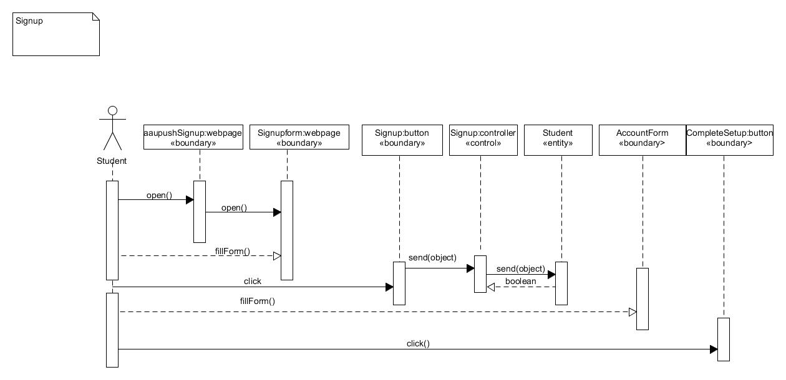

Fig 2.2.3.1 Sequence Diagram - SignUp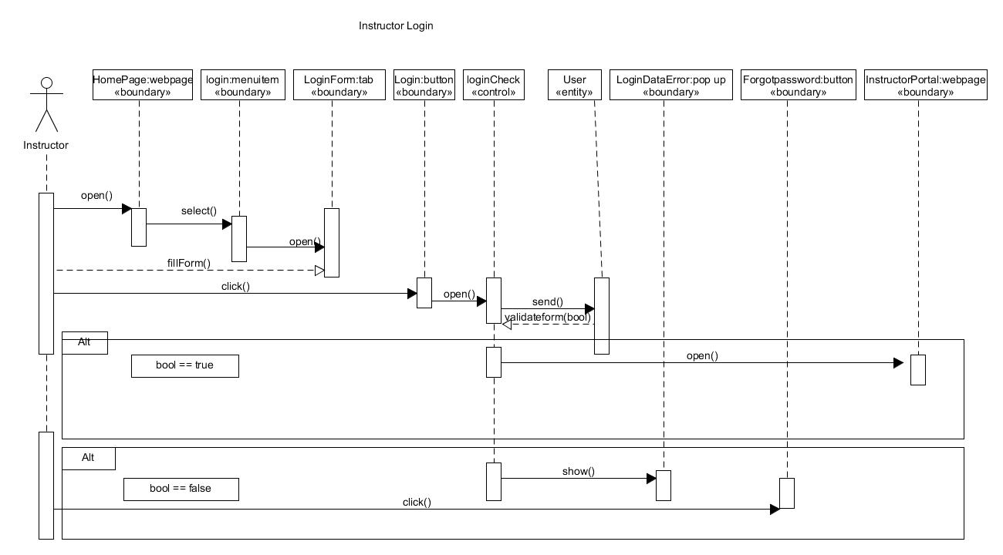

Fig 2.2.3.2 Sequence Diagram - Login

Fig 2.2.3.3 Sequence Diagram - DownloadAssignmentSubmission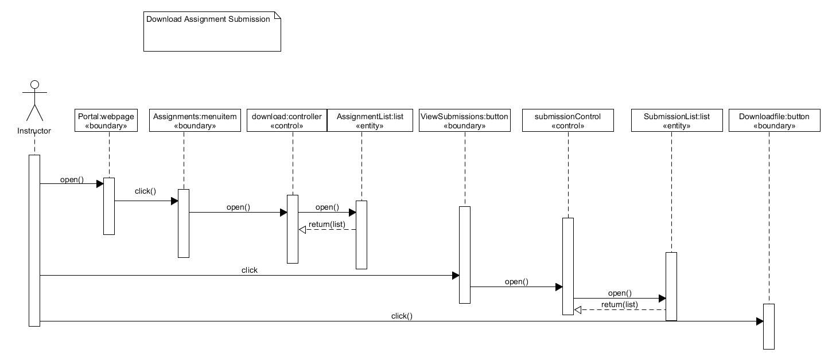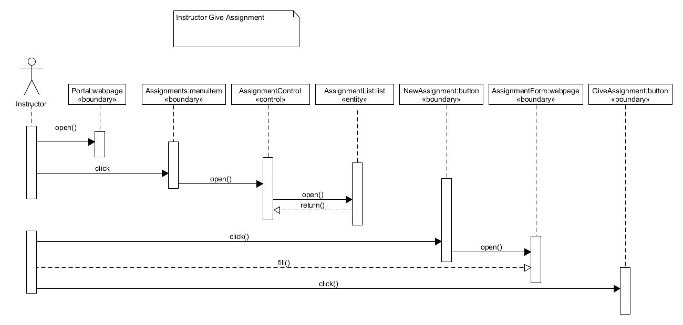

Fig 2.2.3.4 Sequence Diagram - GiveAssignment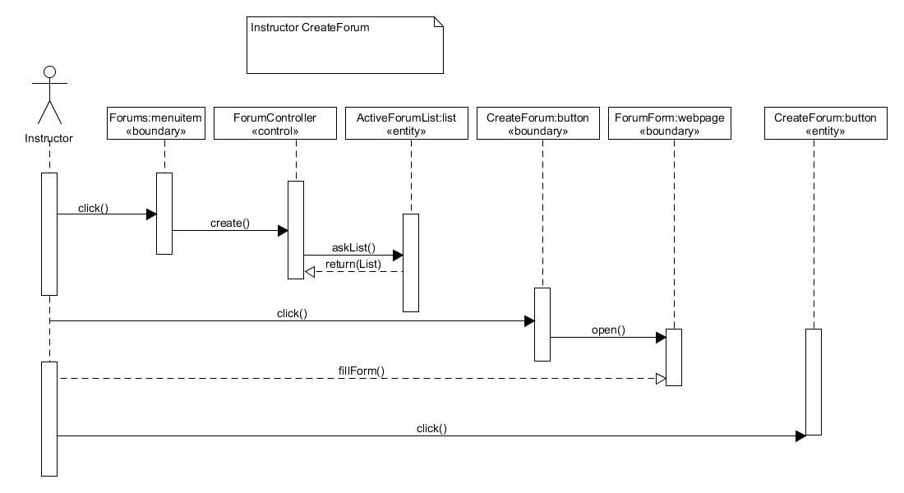

Fig 2.2.3.5 Sequence Diagram - Create Forum

Fig 2.2.3.6 Sequence Diagram - Submit Assignment

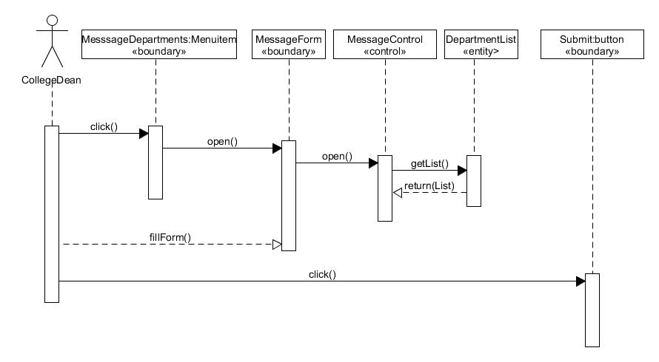

F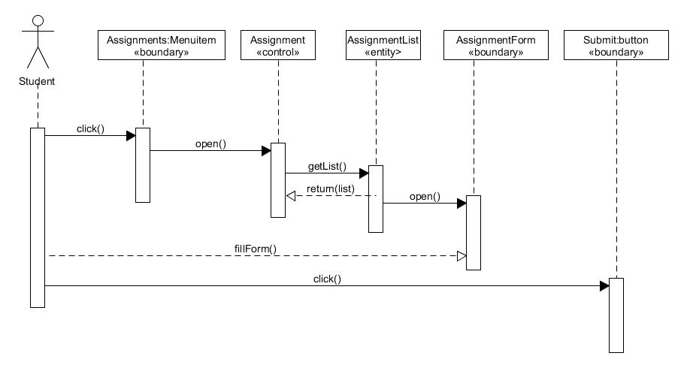ig 2.2.3.7 Sequence Diagram - DeanMessageDepartment

* + 1. Activity Diagram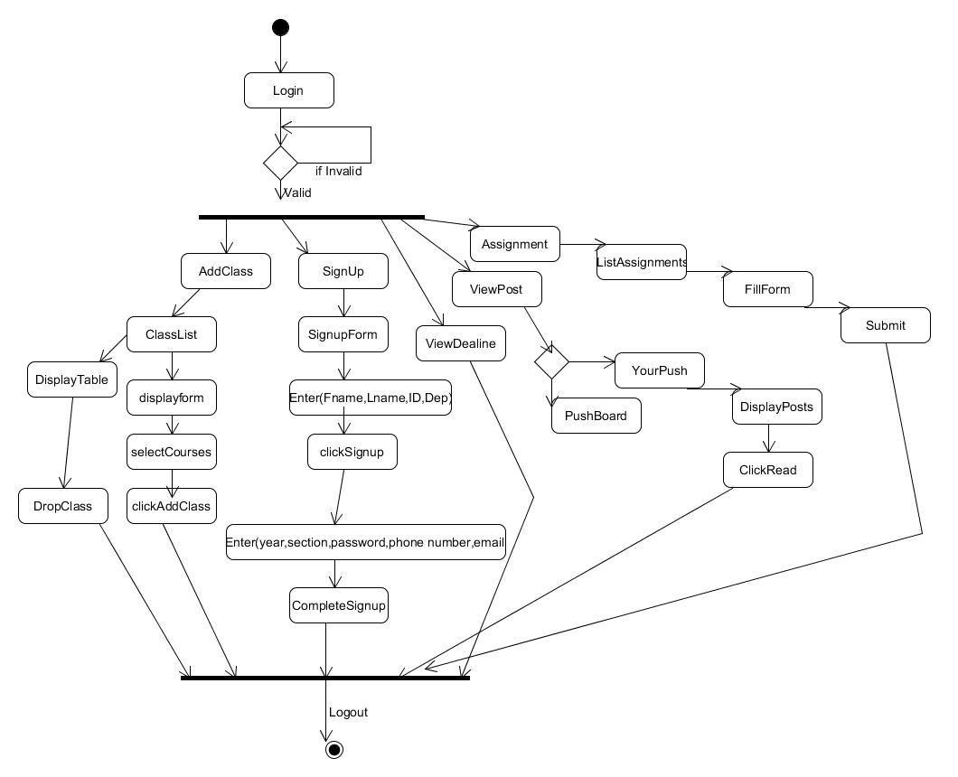

Fig 2.2.4.1 Activity Diagram - Student

* + 1. State Chart Diagram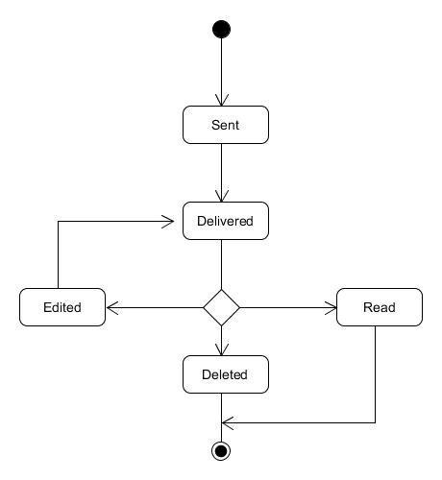

Fig 2.2.5.1 State Chart Diagram of a Post object

* + 1. Object Model
       1. Class Modelling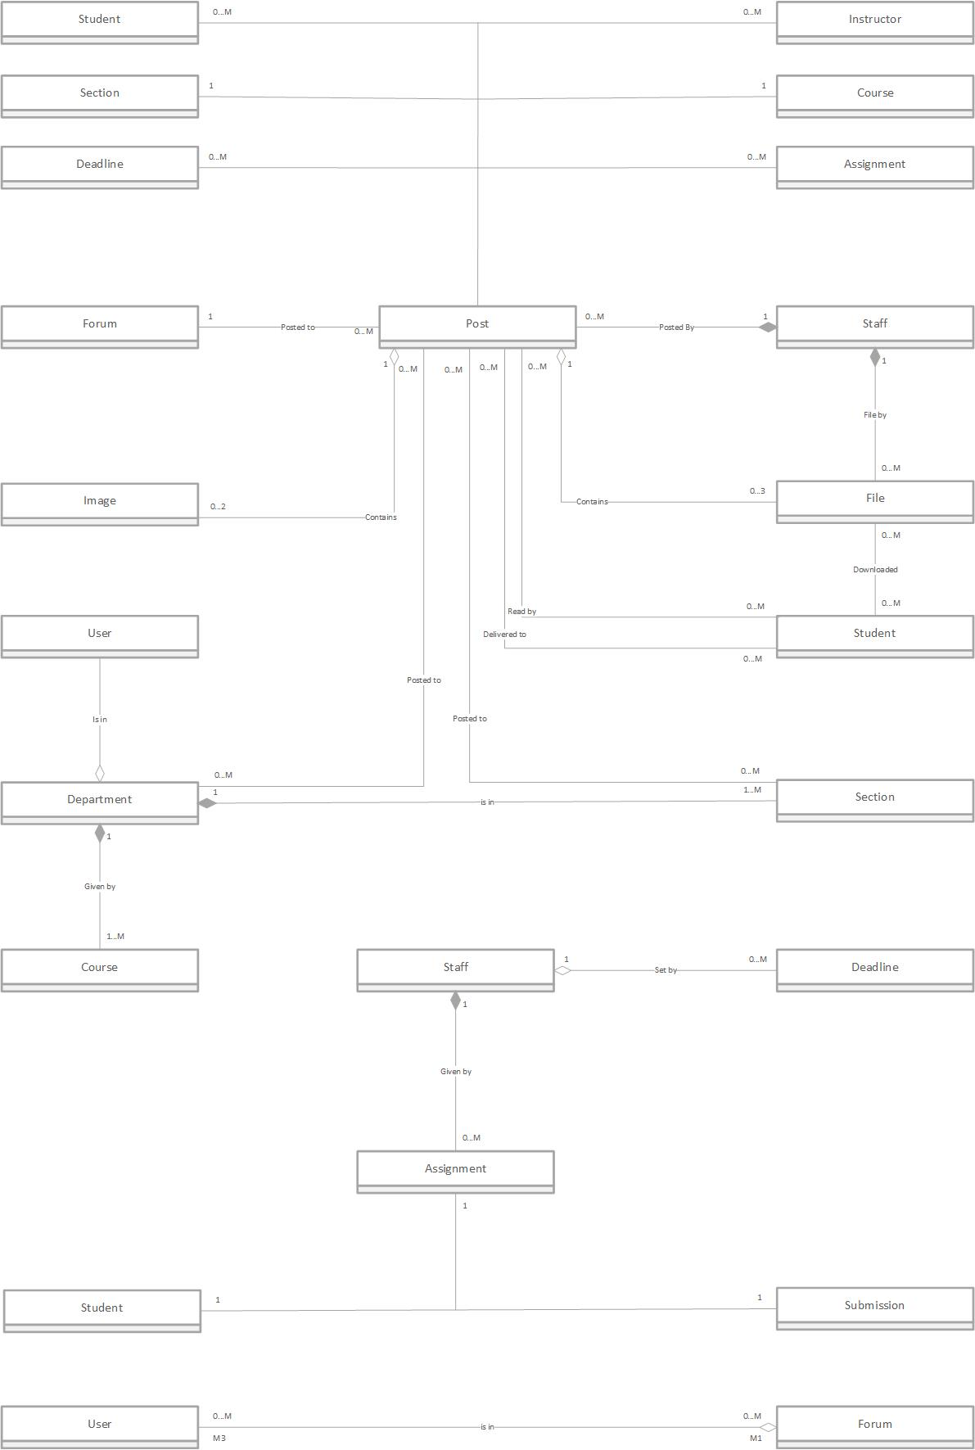
       2. Relationships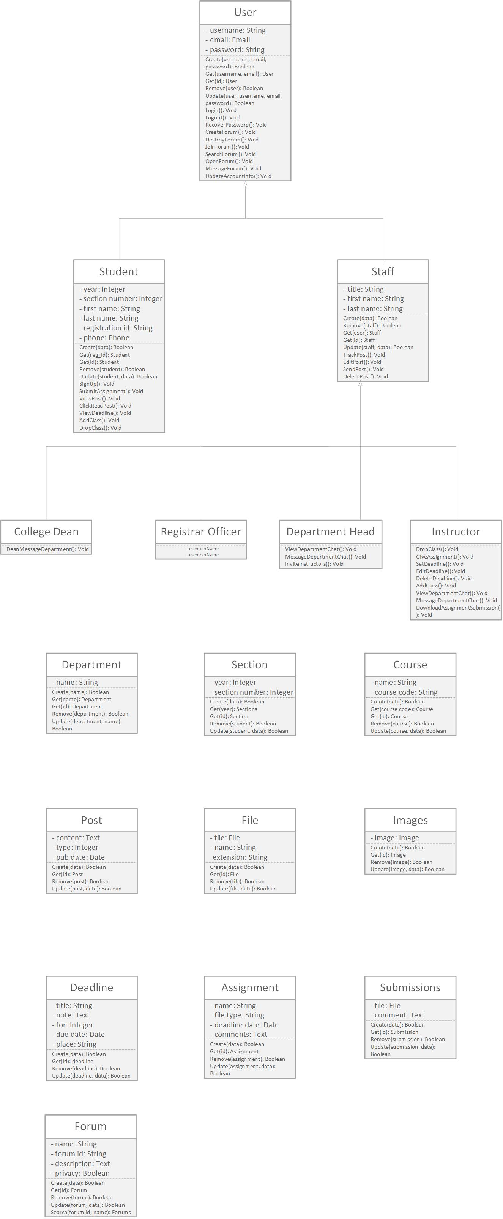
    2. User Interface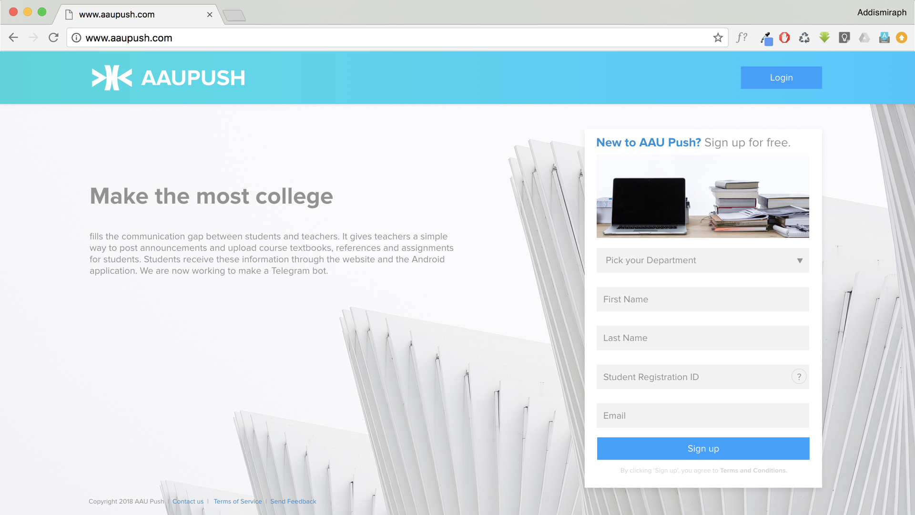

Fig 2.2.7.1 Mockup in Keynote showing the home web page of the Push. Notice on the home page is the sign up form and the login button.

Fig 2.2.7.1.2 Mockup in Keynote showing the web Student Dashboard area.

This mockup shows multiple features:

1. The ‘Read’ button for a post described in ClickReadPost use case is seen.
2. The form to submit an assignment is seen on the right hand side.
3. Under the assignment form there are other deadlines for a test and project.

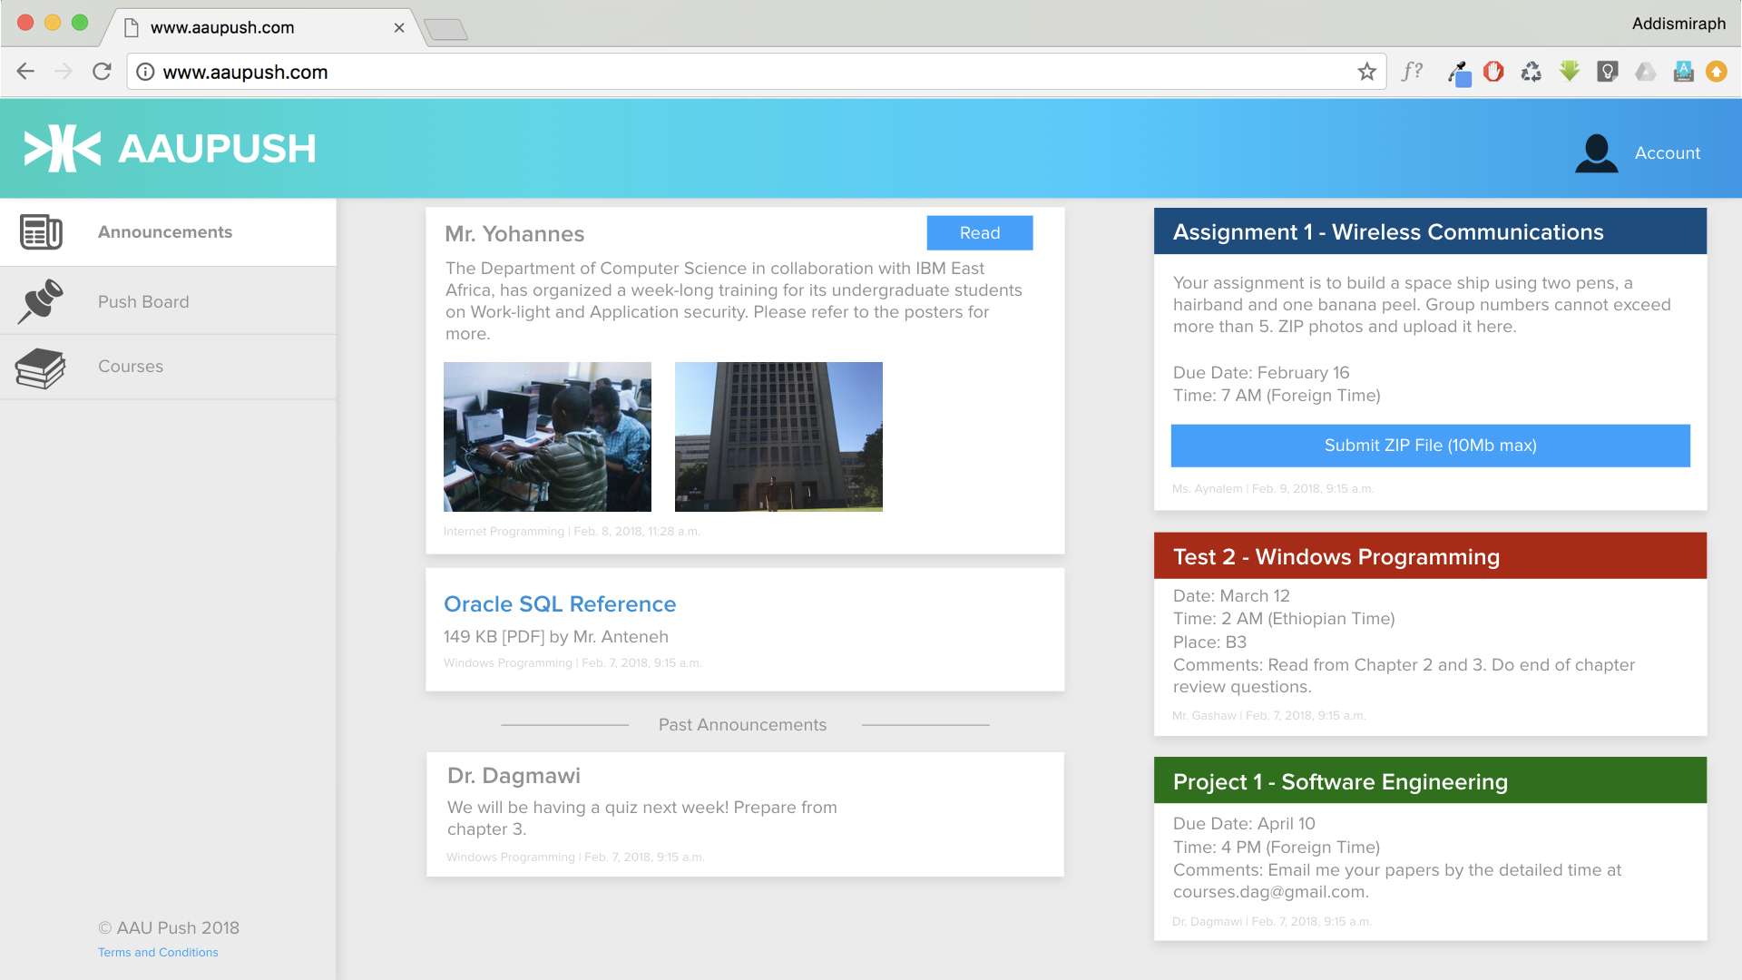

1. System Design
   1. Introduction
   2. Current Software Architecture
   3. Proposed Software Architecture
      1. Overview
      2. Subsystem Decomposition
      3. Hardware/Software Mapping
      4. Persistent Data Management
      5. Access Control and Security
      6. Subsystem Services
   4. Detailed Class Diagram
   5. Packages